1.0 INTRODUCTION
Electromagnetic (EM) ducting in the atmosphere can greatly affect the propagation of radar communications within the lower atmosphere. Consequently, it is a phenomenon that is of considerable interest for many commercial and military entities who seek a better understanding of the conditions under which ducts arise, how they evolve, and ways to mitigate their adverse effects (Wang Q, 2018).
An EM duct can trap radar signals within a layer of lower atmosphere who’s boundaries lie somewhere between the earth’s surface and some altitude overhead. The exact locations of the lower and upper boundary depends on the vertical gradient of atmospheric refractive properties, which in turn depends on atmospheric thermodynamic properties. However, the trapping of the EM signal by the duct is not perfect, with the exception of the trivial case when the earth’s surface serves as one of the boundaries. At both the upper and lower boundaries of the duct (when the lower boundary exists at an elevated altitude) a small amount of the radar signal leaks out when it encounters the boundaries, despite the bending and reflecting that the boundaries induce. This usually results in a reduced and/or distorted signal that may be detected by a radar receiver outside the duct, leading to inaccuracies in radar communications.
The atmospheric property that determines if ducting will take place is atmospheric refractivity, which can be estimated from measurements of atmospheric temperature and pressure, and water vapor pressure. In general, strong inversions in the vertical profile of water vapor and/or temperature result in atmospheric refractivity values that cause ducting. These conditions tend to occur during ocean surface evaporation, subsidence, warm- and dry-air advection, and nocturnal radiative cooling over land.
Detailed characterization of an atmospheric duct and its evolution requires high spatiotemporal resolution measurement of the key atmospheric humidity and thermodynamic properties used to calculate atmospheric refractivity such as vertical profiles of water vapor mixing ratio and temperature. In situ measurements, obtained either on the surface using point sensors or aloft via radiosonde, are limited in terms of the spatial or temporal resolution they are capable of acquiring (Willitsford & Philbrick, 2005).
It has been shown, through both simulation and experiments, that the most effective way to continuously monitor atmospheric refractivity, and therefore track the evolution of an atmospheric duct, is through the use of Raman lidar technology which is capable of measuring vertical profiles of water vapor mixing ratio and temperature with spatiotemporal resolutions superior to that of surface in situ and radiosonde measurements (Willitsford & Philbrick, 2005; Gibson, Craig, & Yilmaz, 1997; Kabral, Patel, Chandrakar, Sing, & Agrawal, 2018). However, a more complete picture of atmospheric duct evolution requires knowledge of the dynamical features of the atmospheric boundary layer. Doppler lidar can be used to characterize these dynamic processes with high spatiotemporal resolution.
We report on the data collection and analysis of refractive and dynamic properties of the planetary boundary layer using Raman-Mie lidars and Doppler lidar near the complex land-sea interface located on the campus of Hampton University in Hampton, VA.

2.0 METHODS
2.1 Instrumentation
In May 2019, Hampton University (HU) and the US Army Combat Capabilities Development Command-Army Research Laboratory (CCDC-ARL) collaborated to acquire fine-scale multi-modal lidar observations of the coastal marine boundary layer (MBL) to better understand interactions between sea and land and the impact this interaction has on local weather conditions and the transport of atmospheric constituents and pollution. The instrumentation was located on the roof of Turner Hall on HU’s campus, which is adjacent to the confluence of the Chesapeake Bay and the Atlantic Ocean (Figure 1). Several lidar sensors were deployed to measure a variety of profiles relevant for characterizing atmospheric dynamics with high resolution.

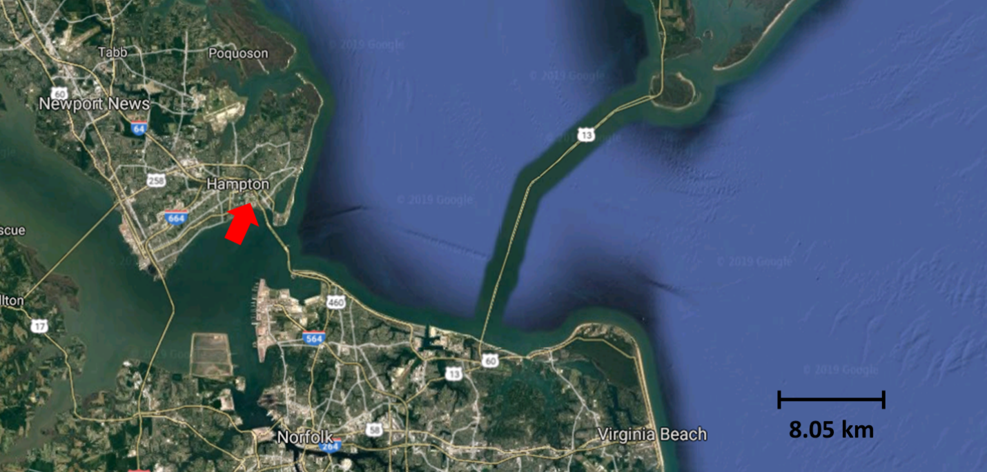
Figure 1 Location of lidar systems on the campus of Hampton University in Hampton, VA.

2.1.1 HU Raman lidars
The Center for Atmospheric Sciences at Hampton University has developed a zenith-viewing Raman-Mie lidar. Key components of the system include (Fig 2): an Nd:YAG laser which emits three fixed laser wavelengths (1064, 532, and 355 nm), a 48-inch non-coaxial Cassegrain telescope receiver with adjustable 1 to 4 mrad field-of-view, an optical separation system built with beam splitters and interference filters, an optical detection system that includes four photomultiplier tubes (PMT) and an avalanche photodiode (APD), and a Licel transient recorder data acquisition system. This lidar can be configured to measure high-resolution vertical measurements (7.5 m) of elastic backscatter from aerosols and clouds at 532 nm and 1064 nm, and at the same time measure vibrational Raman (VR) and rotational Raman (RR) backscatter excited by the 355 nm third harmonic output. The five PMTs are used to detect the elastic lidar signal at 532 nm, the RR signals at 353.35 nm, and the VR signals at 386 nm and 407 nm. The APD is used to detect the elastic lidar signal at 1064 nm. This system design gives the HU Raman-Mie lidar the ability to measure aerosol backscatter and extinction coefficients from the elastic channels, and temperature, water vapor, and lidar ratios from the VR and RR channels, respectively, with a vertical range that extends from the near-surface to the top of the troposphere, depending on atmospheric conditions.
HU has also developed a scanning Raman-Mie lidar for lower tropospheric research (Figure 3). Unlike the zenith-viewing Raman-Mie lidar, the scanning system is capable of obtaining measurements at elevation angles between horizontal and vertical, and at azimuthal angles between 0 and 360 degrees. The system transmits two laser wavelengths, one at 355 nm and the other at 1064 nm, both at 20 kHz. The atmospheric backscatter excited by the lasers is collected by a 14-inch Cassegrain telescope and the return signal is digitized using a Licel data acquisition system. This scanning Raman-Mie lidar acquires measurements of lower tropospheric aerosols with the 1064 nm channel, and can be configured to measure either temperature or water vapor (not simultaneously like the zenith-viewing Raman-Mie lidar).
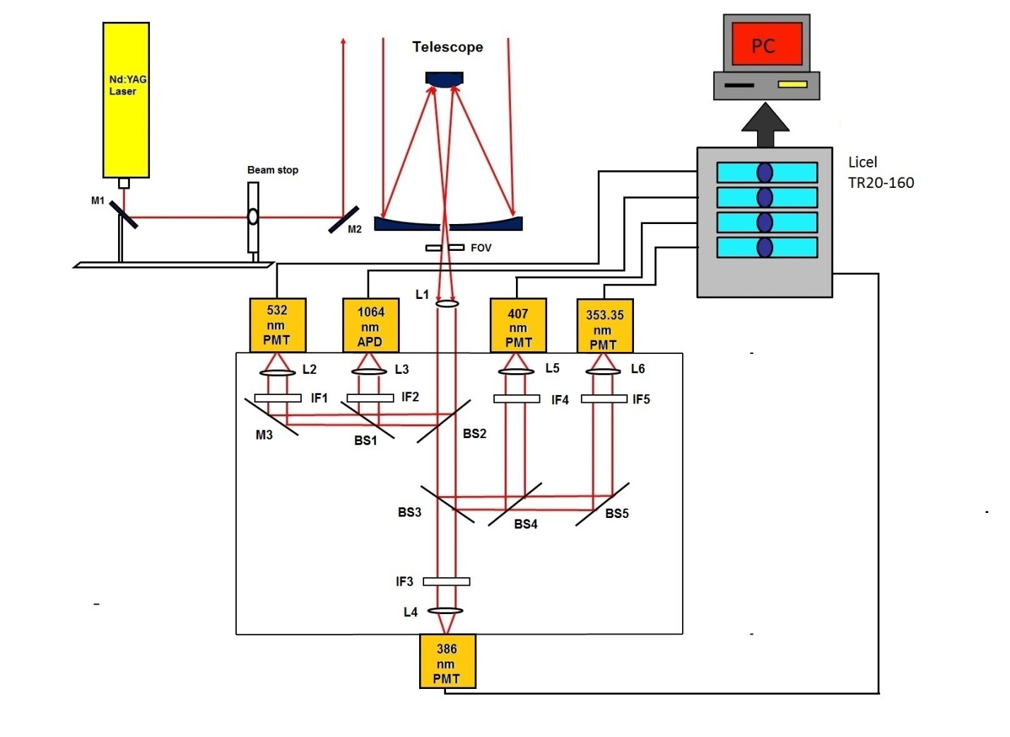
Figure 2 HU zenith-viewing Raman-Mie lidar system (L-lens, M-mirror, BS-beamsplitter, IF-interference filter, FOV-field of view, PMT-Photomultiplier tube, APD-Avalanche Photodetector)
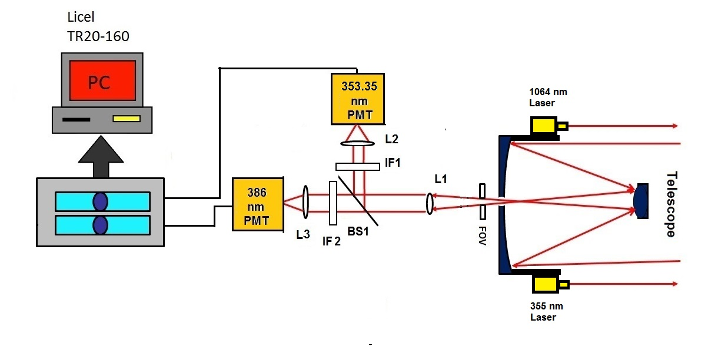
Figure 3 HU scanning Raman-Mie lidar system (L-lens, M-mirror, BS-beamsplitter, IF-interference filter, FOV-field of view, PMT-Photomultiplier tube)

During the period of operation reported on here, the scanning Raman-Mie lidar acquired temperature profiles at an elevation angle of 60⁰, an azimuthal angle of 200⁰, and a temporal resolution of 100 s. The zenith-viewing Raman-Mie lidar measured both temperature and water vapor mixing ratio during the operating period, also with temporal resolution of 100s. Due to the design of the zenith-viewing Raman-Mie lidar, sufficient overlap of the emitted beam and the field-of-view of the collection optic occurs at a relatively high altitude, approximately 1000 m. Therefore, the first range gate with fully accurate data occurs at this elevated altitude. Available data from NASA Wallops Island radiosonde launches that occurred at the same time of the period of operation reported on here was used to correct the profiles obtained with the zenith-viewing Raman-Mie lidar at altitudes lower than 1000 m. Past comparisons of water vapor mixing ratio profiles obtained from radiosonde launches at Wallops Island and HU have consistently been found to be very similar, likely due to both locations being situated in the same general littoral region of Virginia’s eastern shore.

2.1.2 CCDC-ARL Doppler lidar

2.2 Analysis
2.2.1 Atmospheric Refractivity
While the index of refraction (n) of the media through which EM energy propagates determines refractive properties, it is more common to use atmospheric refractivity, defined as N= (n-1) * 10^6, to characterize the propagation of radio transmissions through the atmosphere. The following expression allows for N to be estimated using measurements of key thermodynamic atmospheric properties:
$N=\left({77.6}/T\right)\left(P+{4810e}/T\right)$ (1)
where $T$ is air temperature (K), $P$ is atmospheric pressure (hPa), and $e$ is water vapor pressure (hPa). Water vapor pressure is related to atmospheric specific humidity ($q)$ according to (Arya 1988)
$q={0.622e}/{\left(P-0.378e\right)},$ (2)
and atmospheric specific humidity can be expressed using water vapor mixing ratio through the following expression:
$q=ω/{(1+ω)}.$ (3)
By combining Eq. (2) and Eq. (3), an expression for water vapor pressure can be obtained:
$e={ωP}/{(ω+0.622)}$. (4)
Because the earth’s curvature must be taken into account, it is customary to use modified refractivity $M$, defined as
$M=N+Cz$ (5)
where $z$ is height above the sea surface (m) and C = 10⁶/R where R is the average curvature of the earth (m). By combining Eq. (5) with Eq. (1) and Eq. (4), the modified refractivity can be expressed using temperature and water vapor mixing ratio:
$M=\left({77.6P}/T\right)\left\{1+4810ω/{[(ω+0.622)T}]\right\}$+Cz. (6)
Atmospheric temperature (T) and water vapor mixing ratio ($ω$) can be directly obtained from HU’s Raman-Mie lidars, allowing for continuous monitoring of atmospheric modified refractivity. Gradients in the vertical profile of M are used to characterize the duct. Specifically, the trapping layer, or, the layer of the atmosphere where RF signals will bend back towards the earth’s surface with a curvature smaller than the curvature of the earth, is defined as the condition when dM/dz < 0.

2.2.2 Doppler Analysis

3.0 MEASUREMENT RESULTS

4.0 DISCUSSION

5.0 CONCLUSION

